St. Mary’s Catholic
Primary School
Ysgol Gatholig
Santes Fair

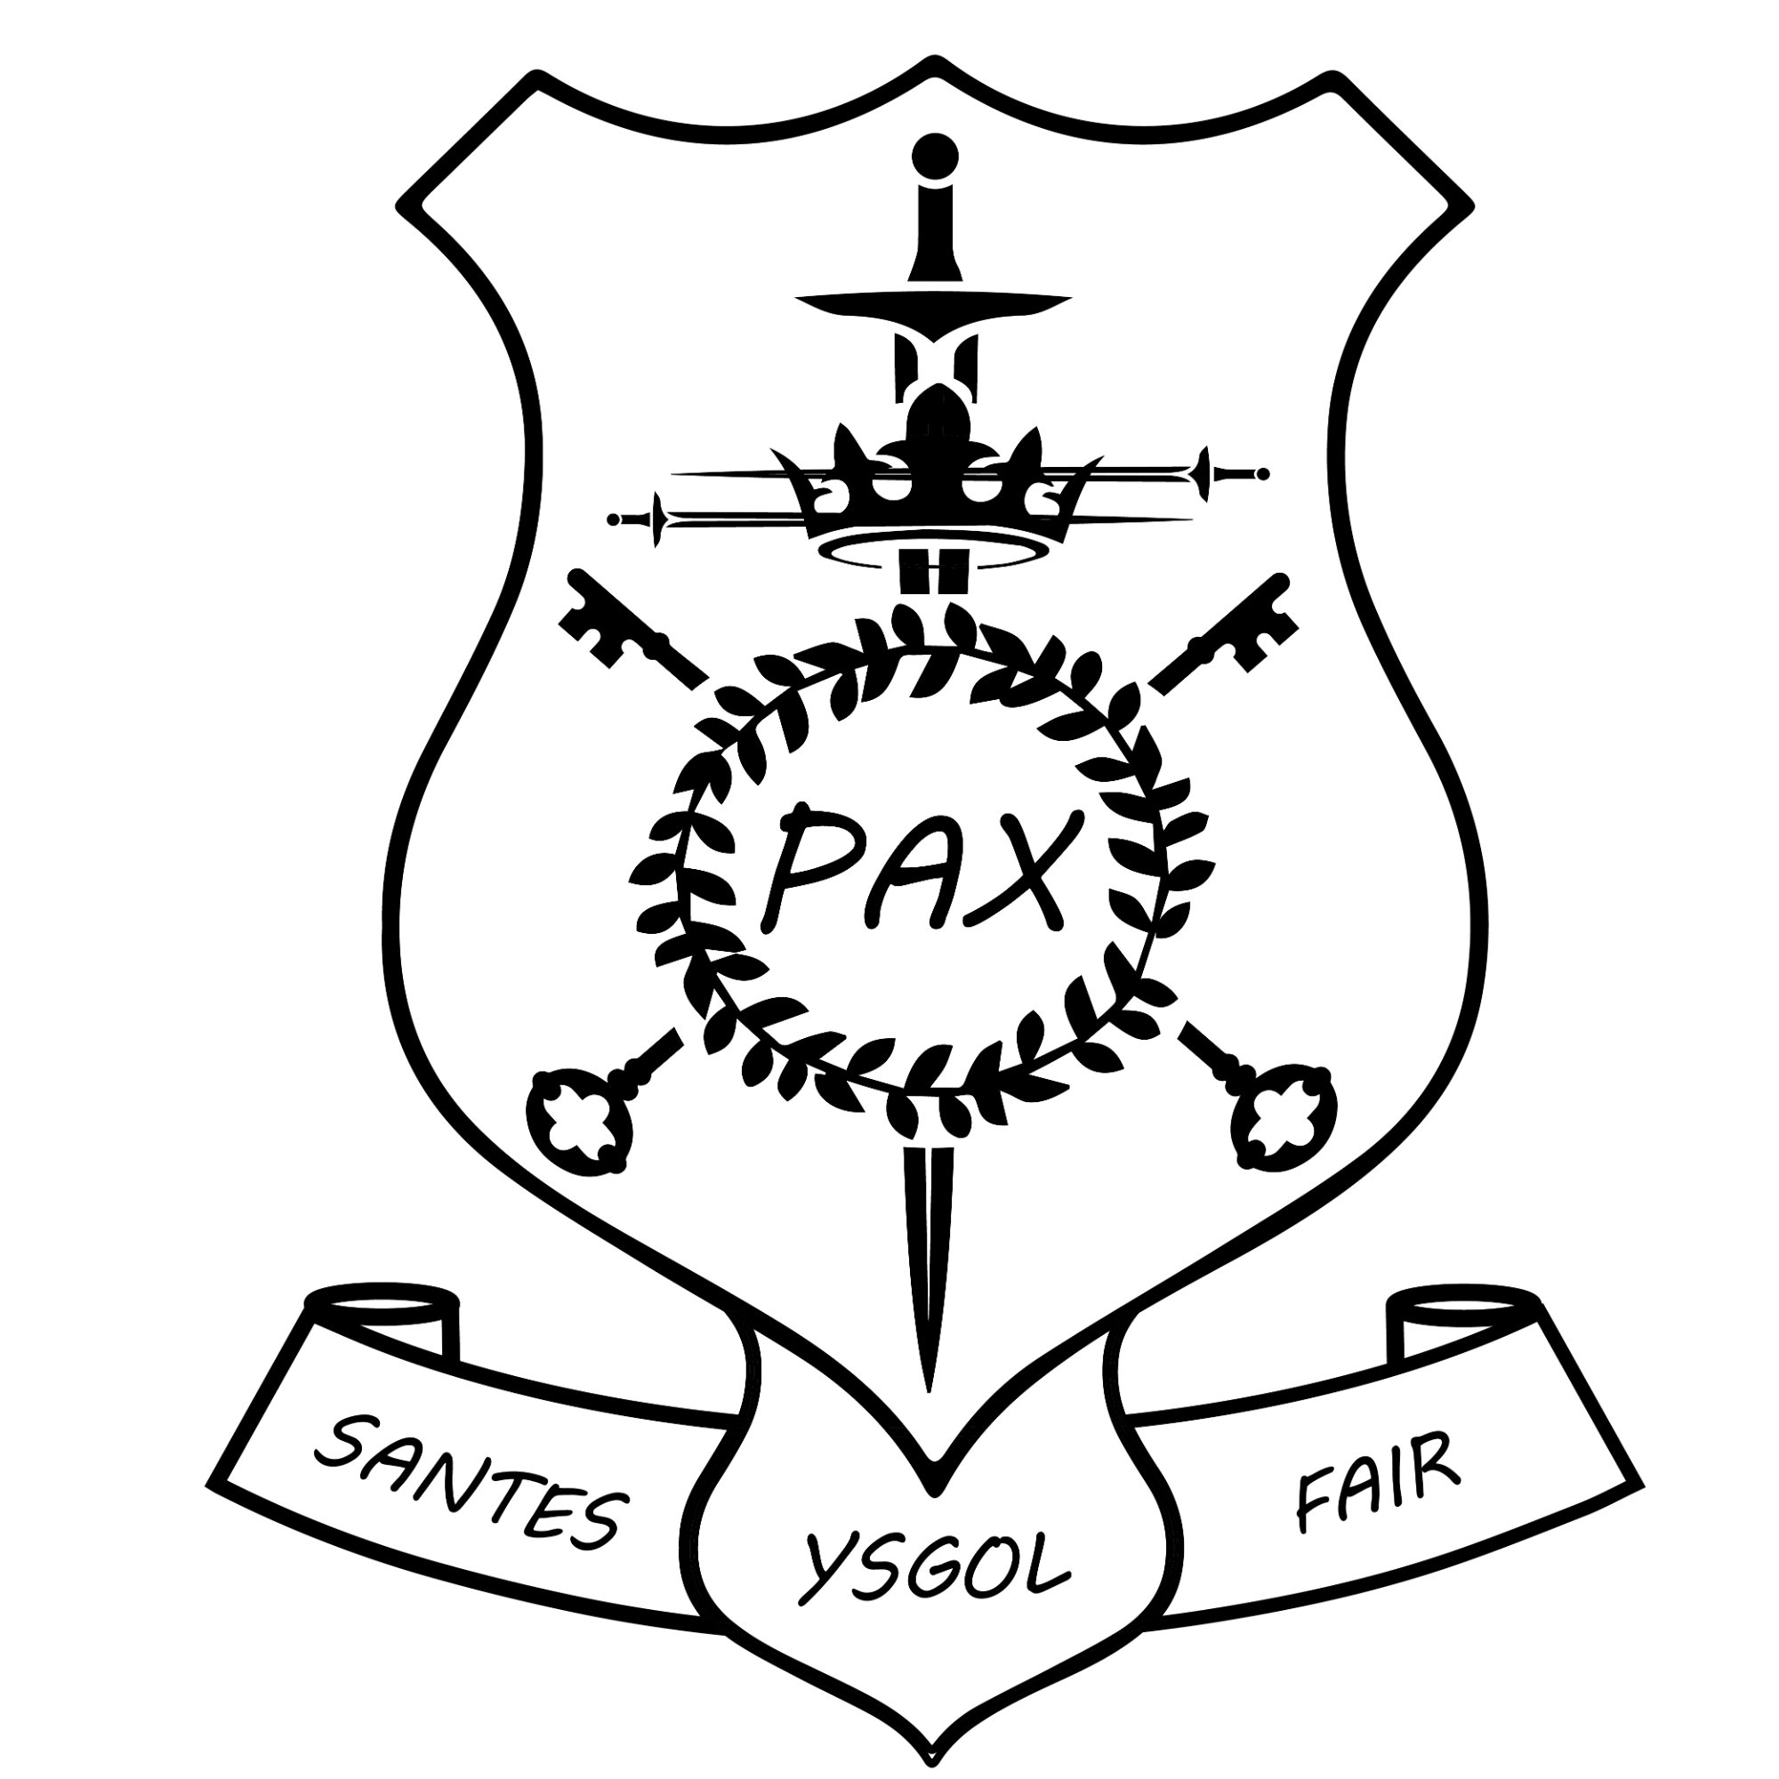

Behaviour Policy

Reviewed and approved by Governors
after consultation with pupils, staff and parents.
Policy Adopted:  Spring 2025 | Signed: | Review date:  Spring 2028


Our Mission Statement

As a Catholic family,
we will do our best to live and
learn as Christ taught us.

Our aims are designed to allow us to live out the Mission Statement.

School Aims

a. To create a community where love, peace and joy are present and to be true to the values of the Gospel and to make our Catholic faith alive by building such a community.
b. To develop a dynamic interaction between home, school and parish and provide a formation for each child to realise their full potential in all aspects of spiritual and moral development.
c. To develop a zest for life and an enjoyment of learning.
d. To allow children to respect all forms of life.
e. To achieve high standards in academic learning.
f. To develop creativity and a love of art, music and drama.
g. To encourage children to learn physical skills and a knowledge and control over their own bodies to compete against themselves and others in order to raise their performance.
h. To have experience of the Welsh Language and be introduced to Welsh culture and others from around the world to reflect the cosmopolitan nature of our school.
i. To make sense of the world around them scientifically and by understanding other people, their history and their environment.
j To foster good attitudes and appropriate behaviour, manners and dress.
k To help children love their school and always to remember their time spent here and the values that they have learned.

Behaviour Policy

‘I would like to speak to you young people: be committed to your daily duties, your study, your work, to relationships of friendship, to helping others; your future depends on how you live these precious years of your life’. Pope Francis.

Our Mission Statement:
As a Catholic Family, we will do our best
to live and learn as Christ taught us.
Introduction - Preamble.

For all of us working at St. Mary’s, it is both our duty and our privilege to be charged with providing the Catholic model needed by our children in the areas of life referenced by Pope Francis, above, through the manner in which we conduct ourselves day in, day out in our school community.

The promotion of excellent behaviour is a central part of the Catholic mission of our school as we encourage all: pupils, staff, parents and governors to follow the model of Jesus Christ. We do all we can to achieve this aim by promoting the virtues identified in our Pupil Profile, which states that:

Pupils at St. Mary’s are growing to be . . .
Grateful for their own gifts, for the gift of other people, and for the blessings of each day; and generous with their gifts, becoming men and women for others.
Attentive to their experience and to their vocation; and discerning about the choices they make and the effects of those choices.
Compassionate towards others, near and far, especially the less fortunate; and loving by their just actions and forgiving words.
Faith-filled in their beliefs and hopeful for the future.
Eloquent and truthful in what they say of themselves, the relations between people, and the world.
Learned, finding God in all things; and wise in the ways they use their learning for the common good.
Curious about everything; and active in their engagement with the world, changing what they can for the better.
Intentional in the way they live and use the resources of the earth, guided by conscience; and prophetic in the example they set to others.

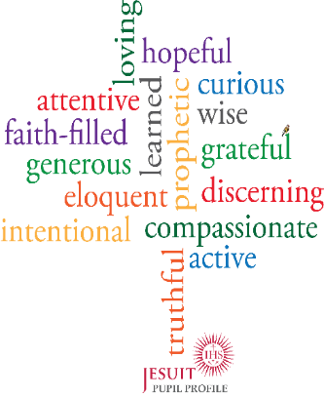
If we are able to put this profile into practice successfully, standards of behaviour will be excellent. All staff will keep it in mind, as positive relationships are continually developed. The school’s positive Catholic ethos will be in evidence from all staff and pupils will be treated with the respect they deserve because they are made in God’s image.

This policy defines how we will achieve the following:
- The creation of an environment that encourages and recognises excellent behaviour.
- A consistent approach in relation to both positive and negative behaviour.
- The promotion of self-esteem, self-discipline and positive relationships.
- A widespread understanding of the school's expectations and strategies in relation to behaviour.
- The appropriate involvement of parents and carers in the implementation of this policy.

Rules.
The following are rules that are applicable across the school. They have been identified following consultation with pupils, staff and governors:

- Always try your best.
- Show good manners; be kind.
- Talk quietly inside the school building.
- Listen first time to all staff.
- Always walk in classrooms, corridors and the hall.
- Keep hands and feet to yourself.

In addition to these, each class may identify three or four particular class rules, if appropriate.
All rules must be displayed in each classroom from Year 1 upwards.
All staff will have high expectations of pupil behaviour and they will ensure that the small number of rules noted above are adhered to in their own classrooms and around the school generally. This needs to be a team effort.

Daily Routines.
It is essential for the smooth running of the school day that the expectations for daily routines are clear to all. All staff will ensure that pupils adhere to the expectations involved.
The routines are:
- Lining up when the buzzer sounds (at the start of the day, breaktimes and lunchtimes): pupils get into line quickly without talking or pushing. It is essential that staff arrive at their class’ line promptly.
- Prayer and Liturgy and Assemblies: pupils walk into the hall, under supervision, silently. They wait silently. Staff continue to have responsibility for their classes at these times and they will deal with any misdemeanours. Staff will stay in the hall for whole school Prayer and Liturgy.
- Dinner Hall: pupils walk into the hall. They use their manners when being served. They talk at a reasonable volume as they develop social skills and they learn to have good table manners.
- Bus lines at the end of the day: pupils line up quietly in their classrooms. Class teachers and support staff lead children out to buses. Atelier and Year 1 lead out to buses first, followed by Year 6 – down to Year 2.

Rewarding Excellent Behaviour.
The most important and effective way to reward positive behaviour is to be found in the day to day noticing of it and commenting on it. A positive mindset from all staff is essential to the establishment and maintenance of excellent behaviour. A smile and the celebration of good behaviour can go a long way!

All classes will operate the Class Dojo platform. Points will be awarded for good behaviour (and learning). This will allow parents to be aware of their child’s good behaviour. If a class does well, in relation to positive behaviour, a ‘Golden Time’ reward may be given on a Friday afternoon. Teachers can list and create areas to reward on Dojo and the number of points to award.
During Prayer and Liturgy on Fridays, we give thanks to God for our talents and for the week’s learning.
Pupils will receive certificates in celebration of their learning during these assemblies. In addition, teachers may informally give a range of rewards to pupils for good behaviour during the course of the week.

Sanctions to Deal with Challenging Behaviour.
At times, pupils’ behaviour will not be as expected. When this is the case, staff will respond in the agreed manner, consistently.
When disruptive and negative behaviour occurs, it will be dealt with in a calm manner, promptly and consistently. Staff will encourage the child to reflect on principles such as kindness, respect, and forgiveness (in line with Gospel values), helping them to understand the impact of their actions and make better choices.
Consequences to negative behaviour should be applied consistently by all staff.
A restorative approach will be employed when dealing with challenging behaviour. Staff will mediate to restore relationships.

We have identified ‘behaviour bands’ along with possible consequences that may be applied, according to the judgement of staff. Please see the appendix.

Procedure for dealing with negative behaviour
- The adult will discuss the negative behaviour displayed with the child and will remind them of our school rules. The adult will remain calm.
- When a child displays low level disruptive behaviour, adults will begin with classroom consequences i.e. verbal warning, change of seat. If behaviour does not improve, or the behaviour is of a more disruptive / serious nature, adults will apply the appropriate consequence within the appropriate Band (see Appendix).
- Staff will record significant incidents of unacceptable behaviour and will usually inform parents via Dojo / face to face meeting / telephone call.
- In very serious circumstances, the Headteacher may decide to exclude a pupil for a fixed term, or permanently. Exclusions are always avoided if at all possible, however, there may be times when all other strategies have been tried and exhausted, or the severity of the incident warrants no lesser action. If an exclusion is necessary, the school will make every effort to work with parents and external agencies to improve the situation and support the pupil on their return to school.

Personnel Involved in Behaviour Management and Support.

Challenging behaviour will be dealt with consistently throughout the school. Where there is a case of persistent ongoing challenging behaviour, another member of staff and/or an external agency may intervene, such as:
Headteacher, Deputy Headteacher, Phase Leaders, ALNCO, ELSA, Shine (Local Authority Wellbeing Service), Educational Psychologist and the Behaviour Support Team.
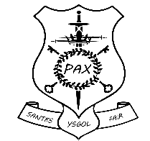
Our School Rules
- Always try your best.
- Show good manners; be kind.
- Talk quietly inside the school building.
- Listen first time to all staff.
- Always walk in classrooms, corridors and the hall.
- Keep hands and feet to yourself.

.
- Keep hands and feet to yourself.

Lunch times

All adults working at St Mary’s should comply with the School’s Behaviour Policy. Kitchen staff, administrative staff, the caretaker and Lunchtime Supervisors will be given the same respect as all other staff within the school. Non-teaching staff are asked to:
- Give and expect to receive respect.
- Within reasonable limits, deal with minor incidents.
- Inform the class teacher at the end of lunch break of any incidents that need to be dealt with by a member of staff.
- Inform the Headteacher of any serious misbehaviour.

The Curriculum and Learning
We acknowledge that an appropriately structured curriculum and a well-planned and engaging learning environment contribute to good behaviour. Thorough planning for the needs of individual pupils, the active involvement of pupils in their own learning and effective feedback all help to avoid the alienation and disaffection, which can lie at the root of some poor behaviour.
It follows that lessons should have clear objectives that are well understood by pupils. Learning activities need to be differentiated to meet the needs of children at different levels of attainment. Teachers will respond to pupils’ learning positively.
Our curriculum is designed to produce happy, curious, independent learners who are able think for themselves in a thoughtful and reflective manner. All of the above will contribute towards the promotion of excellent behaviour.

Classroom Management

Classroom management and teaching methods have an important influence on children's behaviour. The classroom environment gives clear messages to pupils about the extent to which they and their efforts are valued. All teachers will have high expectations of their pupils. Relationships between teacher and children, strategies for encouraging good behaviour, arrangements of furniture, access to resources and classroom displays all have a bearing on the way children behave.
Classrooms should be organised to develop independence and personal initiative. Furniture should be arranged to provide an environment conducive to on-task behaviour. Materials and resources should be arranged to aid accessibility and reduce uncertainty and disruption. Displays should help to develop self-esteem through demonstrating the value of every individual's contribution, and overall the classroom should provide a welcoming environment.
Teaching methods should encourage enthusiasm and active participation for all. Lessons should aim to develop the skills, knowledge and understanding, which will enable pupils to work and play in co-operation with one-another. Praise should be used to encourage good behaviour as well as good learning. Even poor behaviour will be dealt with in a positive manner. Sarcastic or cutting comment is never acceptable.

Communication and Parental Partnership.

We give high priority to clear communication within the school and to positive partnerships with parents, as these are crucial in promoting and maintaining high standards of behaviour.
When the behaviour of a child is giving cause for concern, it is important that all those working with the child in school are aware of those concerns, and of the steps, which are being taken in response. The key professional in this process of communication is the class teacher, who has the initial responsibility for the child's welfare. Early warning of concerns should be communicated to the Headteacher so that strategies can be discussed and agreed before more formal steps are required.
The school will communicate policy and expectations to parents. They will be formally informed of behaviour concerns. In addition, we acknowledge that brief, informal discussions with parents can be very beneficial. They will take place according to the judgement of staff. When formal meetings take place, parents will be treated with respect and their views will be taken into account.

Governors

- Governors will consult with the Headteacher on the development of Behaviour Policy.
- Governors will do their utmost evaluate the curriculum and realise that its quality and delivery have a part to play in promoting good behaviour.
- Governors will require regular reports on attendance and exclusions at their meetings.
- Governors will take account of the advice of the Headteacher and the LA in matters relating to behaviour management.
- Governor’s Annual Report to Parents will contain information on standards of behaviour and attendance.

Appendix

Classroom Warning
Discrete verbal warning in-class
Move to another area in classroom
Playtime consequence
Walk with staff on duty
Age-appropriate time in time out zone
Dojo consequence
0 Dojo point – 1st warning | -1 Dojo point – consequence
Message home
Detention (with teacher)
Inform parents

- Poor attitude to learning  - Lack of effort  - Swinging on chair  - Distracting peers  - Inappropriate talk  - Shouting out  - Running in corridors  - Rough play | - Unkind comments  - Leaving classroom without permission  - Name calling  - Dishonesty  - Persistent defiance  - Chewing gum  - Physical aggression  - Swearing

Band 1
Detention (with SLT)
Inform parents | Behaviour reflection task

Meeting with parents
Home School book
Band 2
- Persistent ongoing Band 1 behaviour
- Verbal abuse / lack of respect towards staff
- Deliberate damage to school property
- Unprovoked fighting with malicious intent

Detention (with HT)
Inform parents | Behaviour reflection task

Behaviour Report
Behaviour tracked, monitored and reviewed daily
Internal Isolation
Learning / break times to be completed in an alternative provision.
Fixed term / Permanent exclusion

- Persistent ongoing Band 2 behaviour
- Absconding
- Possession / use of weapon / inappropriate substances
- Theft

Band 3

Examples of Challenging Behaviours

Outside Agency support will be sought when necessary * This is not an exhaustive list. *
e.g. Early Help, CART, Youth Justice.

