St. Mary’s Catholic
Primary School
Ysgol Catholig
Santes Fair
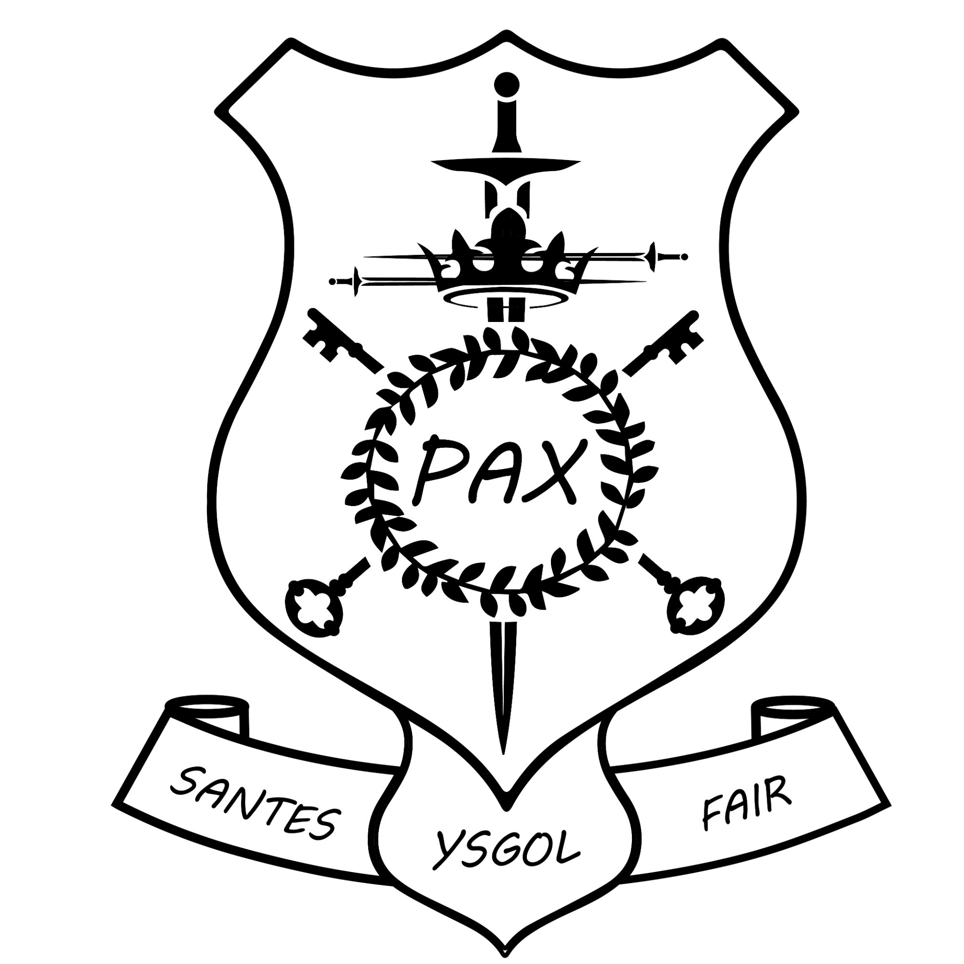
Assessment Policy

Reviewed and approved by Governors
after consultation with staff
Policy Adopted:  Spring 2025 | Signed:  Rachel Azzopardi  David Bolton | Review date:  Spring 2028

Introduction
The ultimate purpose of assessment at St. Mary’s is for it to make a significant contribution towards ensuring that individual pupils make optimum progress in their learning and that standards across the school, as a whole, are excellent and as high as possible. The practices highlighted in this policy have been designed to take into account the expectations included in the Curriculum for Wales and the Principles of Progression in particular. Cluster based work has taken place to allow our family of schools to arrive at a common understanding of progression.
The high quality assessment practices described in this policy will allow teachers to have a clear picture of the learning development of every pupil under their tutelage and of the targets they have for improvement (this, in turn, will inform the planning of learning). Leaders and governors will also have a secure understanding and grasp of current performance and of priorities for the future.
Assessment will be summative, formative and ipsative in nature. We recognise that formative assessment has the greatest potential to raise standards. Black and William (1998) note that:
Innovations that include strengthening the practice of formative assessment produce significant and often substantial learning gains.

Each of these assessment forms are referenced, in turn, below:

Summative Assessment
Summative assessment allows us to analyse how well pupils have attained at the conclusion of a period of learning (long or short term). It is also used to identify how well a particular year group or cohort of pupils have performed at a particular point in time. In addition, it allows leaders to quantify how well a particular teacher, phase or the whole school is performing. Practices in this area are as follows:
- Assessment against the NBRIA levels at the conclusion of each term.
- An end of academic year level for Religious Education.
- An end of term assessment in Mathematics (White Rose Maths).
- National Tests for pupils in Y2-Y6, taken in the Summer Term. Teachers may decide to make use of a preparatory test or of the familiarisation materials using their professional judgement.
- Lexplore Assessment to be used alongside Reading assessments (Salford and Holborn).
Ipsative Assessment
Ipsative assessment allows us to measure progress against a baseline. Teachers often take part in research activities, during which ipsative assessment has a significant role to play. In addition we conduct:
- An On Entry Baseline Assessment.
- A Reading (Salford and Holborn) and Spelling age (Schonell) assessment in Autumn and Summer Term.
- An end of term Phonics Assessment.
- A termly Religious Education Assessment.

Formative Assessment
Formative assessment has the greatest potential to raise standards for pupils. We define it as:
Assessment carried out during the instructional process for the purpose of improving teaching and learning. What makes formative assessment formative is that it is immediately used to make adjustments so as to form new learning (Shepard, 2008).
Whilst conducting formative assessment, staff will keep the following key questions in mind:
• Who is and is not understanding the lesson?
• What are this pupil’s strengths and needs?
• What misconceptions do I need to address?
• What feedback should I give pupils?
• What adjustments should I make to instruction?
• How should I group pupils?
• What differentiation do I need to prepare?
The use of the strategies noted below will be the focal points of the school’s formative assessment, as they have been identified through research as yielding the largest achievement gains for pupils:
- Use of classroom discussions, classroom tasks, and home-learning to determine the current state of pupil learning/understanding, with action taken to improve learning/correct misunderstandings.
- Provision of descriptive feedback, with guidance on how to improve, during the learning (refer to marking policy, below, for detail).
- Development of pupil self and peer-assessment skills.
The use of high quality discussion, as referred to above, will focus not only on curriculum content but also on the skills of learning that are being developed, in line with the school’s Building Learning Power philosophy.
Assessment for Learning (AfL)
Assessment for Learning (AfL) will play an essential formative assessment role. It will ensure that pupils are fully involved in the development of their learning in an age-appropriate manner. To this end, three key questions for pupils to grapple with will be: where am I going? Where am I now? and how can I close the gap?
The following strategies for AfL will be employed:

Where Am I Going?
Strategy 1: Provide pupils with a clear and understandable vision of the learning target.
Strategy 2: Use examples and models of strong and weak work.

Where Am I Now?
Strategy 3: Offer regular descriptive feedback.
Strategy 4: Teach students to self-assess and set goals.

How Can I Close the Gap?
Strategy 5: Design lessons to focus on one learning target or aspect of quality at a time.
Strategy 6: Teach students focused revision.
Strategy 7: Engage students in self-reflection and let them keep track of and share their learning.

We recognise that the quality of feedback (commentating) received by learners is an essential factor in creating rapid rates of pupil progress.

‘Feedback to any pupil should be about the particular qualities of his or her work [learning], with advice on what he or she can do to improve and should avoid comparisons with other pupils’ (Dylan Wiliam).

AfL Strategies
Self-Assessment – Learners reflect on their own learning and evaluate their work.
Peer-Assessment – An opportunity for learners to evaluate the quality of one another’s work in relation to a set of agreed criteria.

AfL stamps
Smiley faces | Progression Step 1
Learners reflect on their learning and colour the face to assess their work.
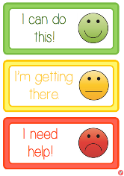


Star and Wish | Progression Step 2
Learners self-assess their learning and, when appropriate, record something that they are proud of / feel that they completed successfully in their learning (star).

Learners record something that they feel they could improve (wish).

Where learners are not ready to record, they will discuss their star and wish with their teacher and teachers will record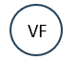.


2 Stars and a Wish | Progression Step 3

Learners self-assess their learning and choose 2 things / aspects that they feel meet the success criteria and 1 thing / aspect that could be improved.

This can also be used for peer-assessment.
A signature should be added to make peer assessment strategy evident.

In addition to the above, a range of AfL labels will be used as and when appropriate (Appendix 2).

Questioning
Teachers use questioning to assess pupils and to ‘gauge how successful they have been in securing learning from their teaching.’ (Tom Sherrington)

Teachers employ a repertoire of questioning strategies:

- Cold Calling
- No opt-out
- Checking for understanding
- Probing
- Say it again, better
- Think, pair, share
- Whole-class response

(Tom Sherrington’s blog, Great Teaching: The Power of Questioning can be found here)

Marking
Marking plays a key role in the formative assessment practice of the school. The marking policy is as follows:
The school’s marking has the principle aim of furthering the learning of all pupils. The processes highlighted here have been agreed after consultation with staff and they aim to be meaningful, manageable and motivating. We recognise that approaches need to differ between the phases and therefore, practices are noted here that apply to both separately. The philosophy involved, however, is consistent. We refer here to the headings used by the Education Endowment Foundation (EEF) in their paper ‘A Marked Improvement.’ Click here to read.

1 Grading
At St. Mary’s, we do not grade individual pieces of learning as we recognise that it can be demotivating and that it can cause pupils to ignore formative assessment comment. We do however make use of:
- regular spelling and mental Mathematics assessment which yield a score (PS2-3)
- assessment tasks in Religious Education using NBRIA levels at the end of each topic that are recorded on pupils’ individual target sheets; a formal assessment task is also carried out termly.

2 Corrections
We distinguish between mistakes (made when a pupil does know a concept) and errors (caused by a pupil not understanding) through marking and/or comments. The former is likely to need no more than a ‘nudge’ whilst the latter is likely to need clarification or re-teaching. A marking grid (Appendix 1) is used throughout the school and is displayed in classrooms to enable pupils to understand what the symbols mean. Verbal feedback is given in on-going dialogue with pupils, where errors and mistakes are highlighted. This enables more in-depth questioning/understanding about their learning. When learning is marked at a later time the marking grid is used.
3 Thoroughness
We believe that it is important for teachers or Learning Support Officers to acknowledge children’s learning even when in-depth marking is not carried out, in order that children, parents and others know that it is valued.
A marking grid is used to mark learning. In-depth marking, linked to the WALT, is used for the following:
- Extended writing (in any curriculum area).
- Focused assessment tasks in Religious Education.
- Extended problem-solving or investigative learning in Mathematics and Science.

In-depth marking will include:
- Welsh comment.
- Constructive feedback.
- Next step comment (close the gap marking).

4 Pupil Responses
We acknowledge that it is important for pupils to consider and respond to written comments. Pupil responses are not expected for every piece of learning; rather, we encourage them for the tasks listed above (see point 3) which require in-depth marking. Pupils will respond to questions and corrections highlighted.

5 Verbal Feedback
As a Building Learning Power and Advanced Thinking School, we enable pupils to develop skills as learners and understand that these are valued equally with curriculum content. Teachers and pupils regularly discuss what and how they have learned (these conversations are indicated using the marking grid). In addition to this verbal dialogue and feedback, teachers’ in-depth comments indicate the way forward. Where appropriate, they may also seek to extend the learning further by asking a written question to which the pupil responds for selected pieces of learning (point 3).
6 Targets
Teachers always set specific targets for learning in the following ways:
- Clear lesson objectives which are displayed at the start of each lesson, using the form of We Are Learning To (W.A.L.T.)
- Short term specific targets are noted in the in-depth marking and the next step is highlighted.

The impact of this policy will form a regular part of the school’s MER work. When pupils’ learning is sampled, for example, the impact and effectiveness of assessment practices will be judged. This policy will be reviewed in 2028.

Appendix 1

Agreed Symbols to be Used When marking:
Marking Grid for Pupils
The Target | Symbol | Action
Indicate a good point or correctness |  | Possible improvements could still be suggested
Indicate an incorrect point |  | Discuss or write down correct answer
Indicate that something doesn’t make sense |  | Write an explanation in the margin or at the end of the piece
Indicate a spelling mistake | Underline the word | Write the correct word, first three letters or just ‘Sp’ in line with school spelling policy
Revise spelling | SP | Repeat correct spelling three times *
Indicate next step in learning | => | Complete the challenge/ consolidation question
A word or phrase is missing |  | If possible, put a few words in so the pupil can see where they have gone wrong
Indicate a missing full stop |  | If possible, put in a few so the pupil can see where they have gone wrong
Indicate a missing capital letter or where it has been used incorrectly |  | Help the pupil and put a few in so that they can see where they have gone wrong
Indicate that a new paragraph is required | //
* Maximum 3 spelling words to revise. These should only include age-appropriate expectations for spelling words or key vocabulary for that session.

Marking Grid for Staff
The Target | Symbol | Meaning
Indicate understanding in relation to the WALT |  | Not achieved
Indicate understanding in relation to the WALT |  | Low level of understanding
Indicate understanding in relation to the WALT |  | Good level of understanding
Indicate understanding in relation to the WALT |  | Excellent level of understanding
Indicate support needed | I | Work completed independently
Indicate support needed | S | Support needed to complete task (note briefly e.g. teacher / scaffolds)
Grammar session | G | Placed in the corner of the page to indicate lesson focus
Indicate that verbal feedback has been given | VF | Element of work has been discussed and guidance of how to improve/ uplevel work **
Indicate that work has been modelled | M | Pupil has worked collectively to produce work and copied a modelled task

** ‘VF’ symbol should be placed next to the corrections that has been identified and discussed.

Welsh Comments

Da / Da iawn | Good / very good
Gwych | Great
Arddechog | Excellent
Bendigedig | Fantastic
Hyfred | Lovely
Gwaith da | Good work
Ti'n seren! | You’re a star!
Ymdrech dda | Good effort
Gwaith arddechog | Excellent work
Gwaith taclus | Neat work
Cofia… | Remember….
Dw i'n hoffi hwn | I like this
Llun da | Good picture
Dal ati! | Keep it up!
Diddorol! | Interesting!

Appendix 2

Example of Self and Peer Assessment Strategies

Smiley faces Traffic Lights
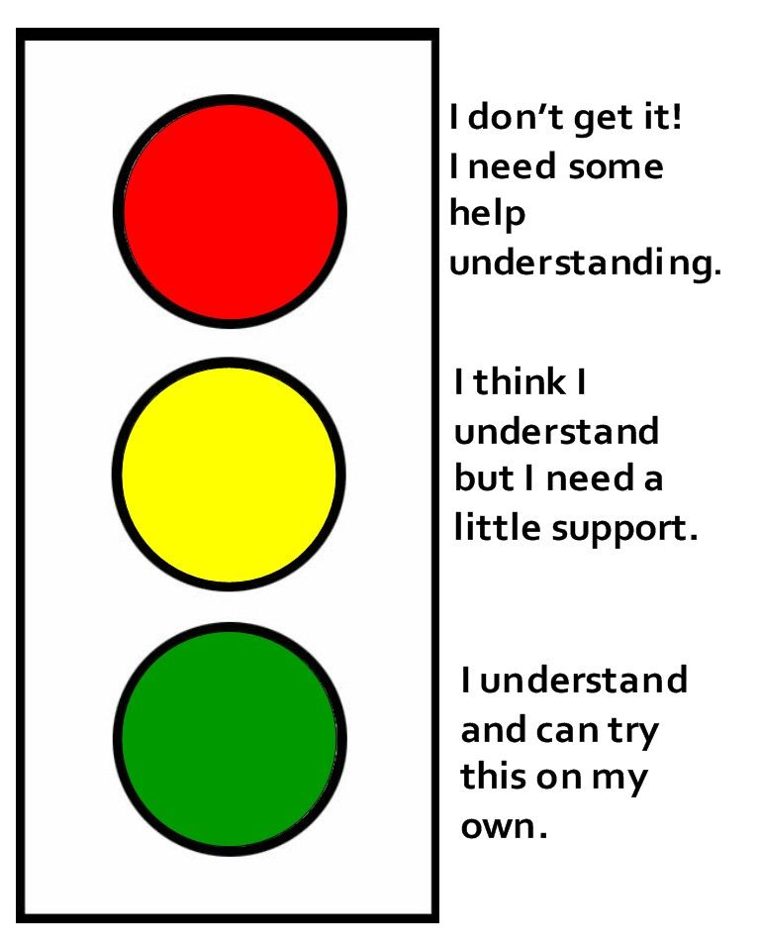
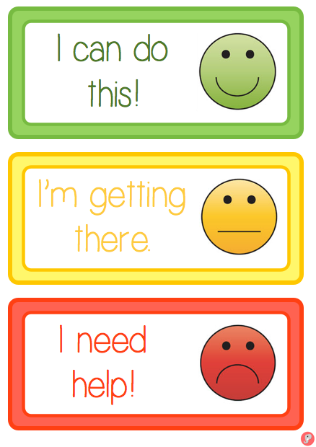

Thumbs up and down

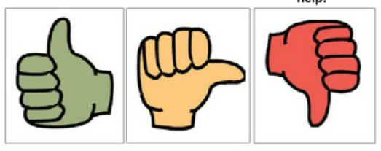

AfL Label Examples
Templates can be found here.

Send a text message
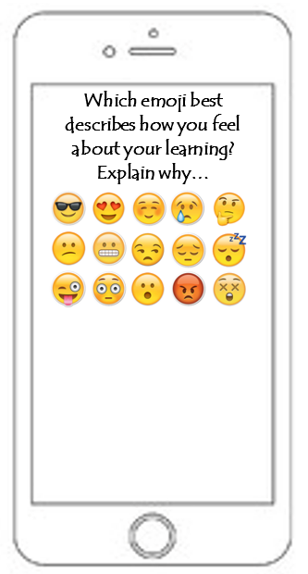


Feedback Burger Gimme 5!

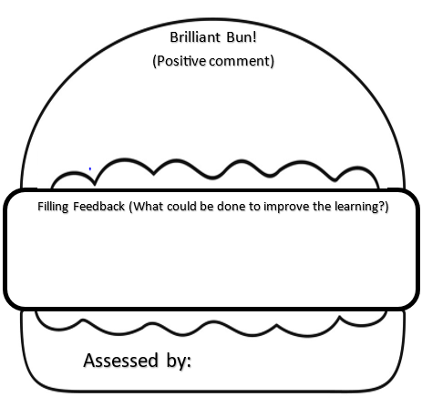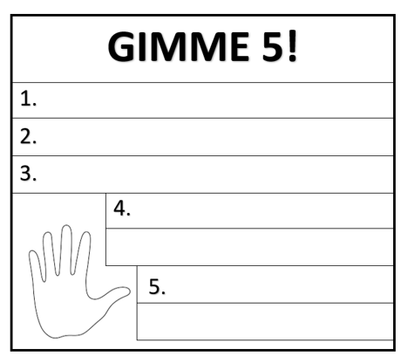

WWW, EBI
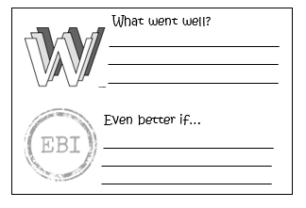

TAG Feedback
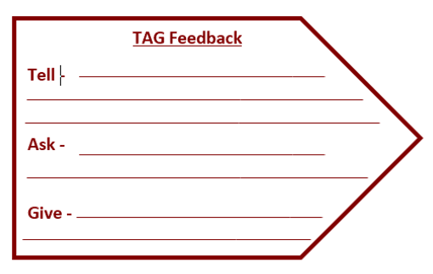
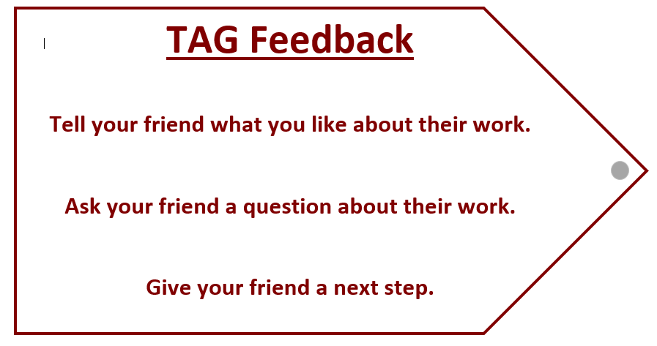

Success Criteria



